Jeremy Scheuerman

Dr. Peter Wang

Lab 5

5.1

1. 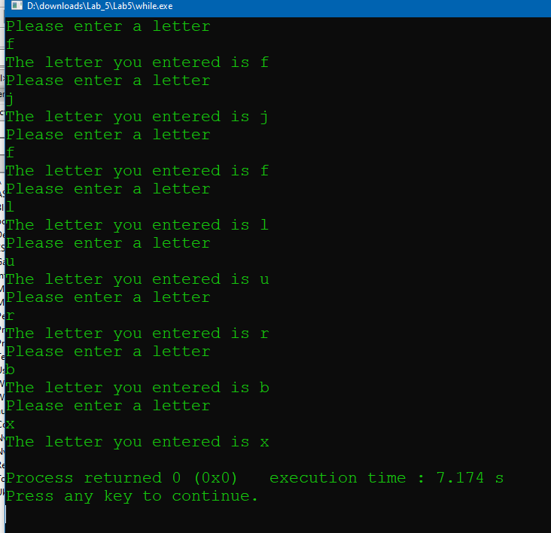

The program dosen’t tell you that you need to enter x to stop the loop

2. 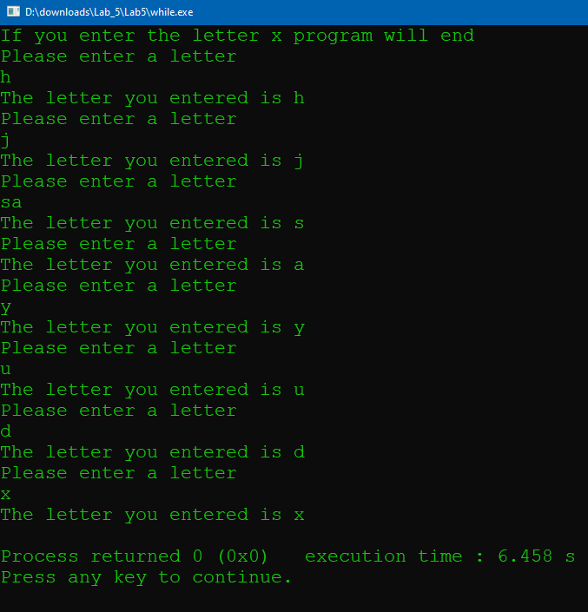

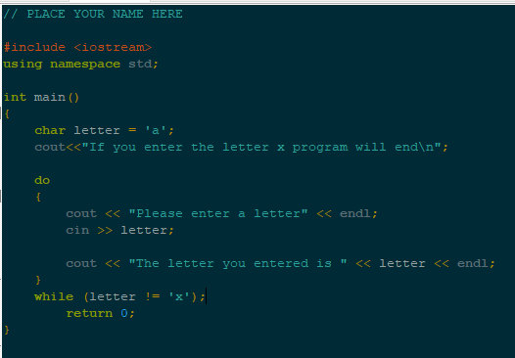

3. 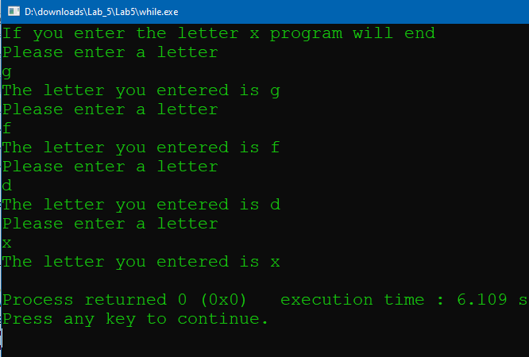

Source Code

//Jeremy

#include <iostream>

using namespace std;

int main()

{

char letter = 'a';

cout<<"If you enter the letter x program will end\n";

do

{

cout << "Please enter a letter" << endl;

cin >> letter;

cout << "The letter you entered is " << letter << endl;

}

while (letter != 'x');

return 0;

}

4. 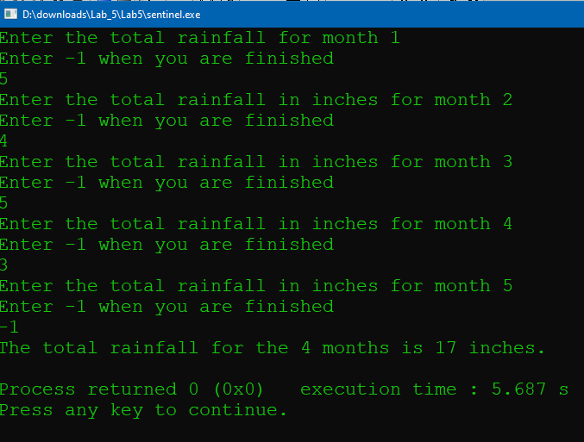

5.

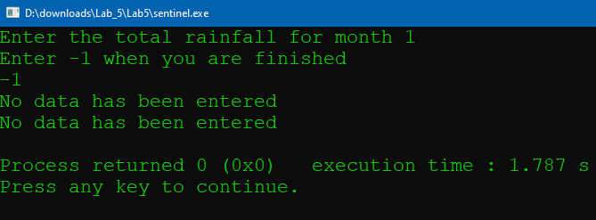

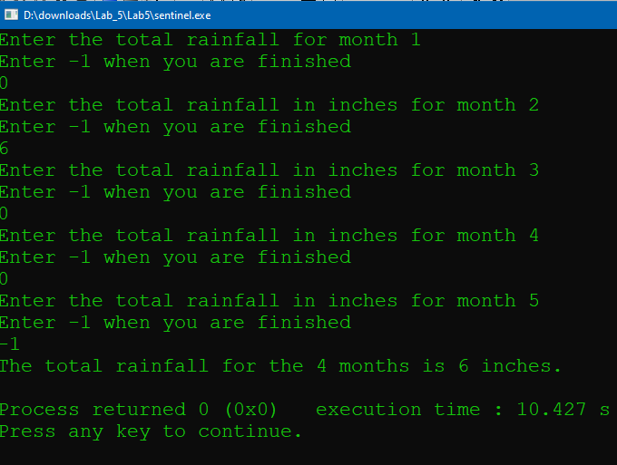

6. This code is to prevent the program from executing if no months have been entered

Source code

// This program illustrates the use of a sentinel in a while loop.

// The user is asked for monthly rainfall totals until a sentinel

// value of -1 is entered. Then the total rainfall is displayed.

// PLACE YOUR NAME HERE

#include <iostream>

using namespace std;

int main()

{

int month=1;

float total = 0, rain;

cout << "Enter the total rainfall for month " << month << endl;

cout << "Enter -1 when you are finished" << endl;

cin >>rain;

// Fill in the code to read in the value for rain

// Fill in the code to start a while loop that iterates

// while rain does not equal -1

while (rain!=-1)

{

// Fill in the code to update total by adding it to rain

total+=rain;

// Fill in the code to increment month by one

month+=1;

cout << "Enter the total rainfall in inches for month "

<< month << endl;

cout << "Enter -1 when you are finished" << endl;

cin>>rain;

// Fill in the code to read in the value for rain

}

if (month == 1)

cout << "No data has been entered" << endl;

if (month == 1)

cout << "No data has been entered" << endl;

else

cout << "The total rainfall for the " << month - 1

<< " months is " << total << " inches." << endl;

return 0;

}

5.2

1. 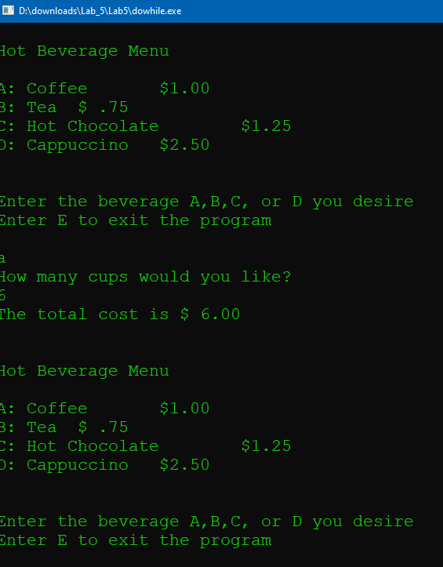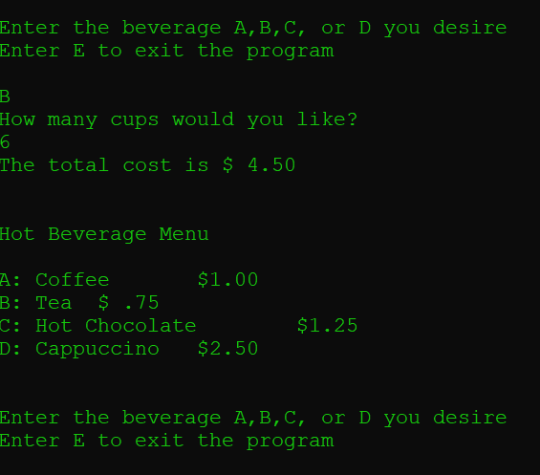

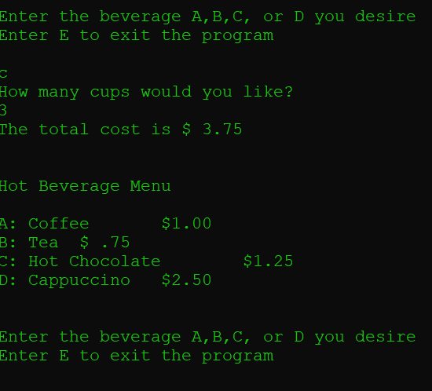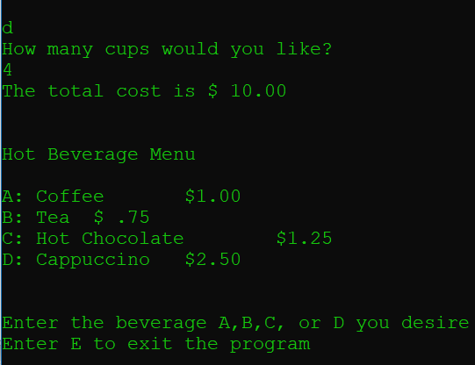

2. Using another letter shows

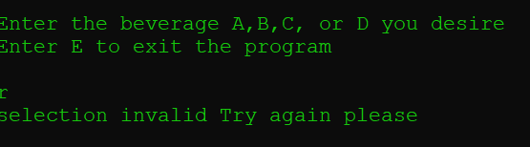

Using 2 letters starts an infinite loop

3. 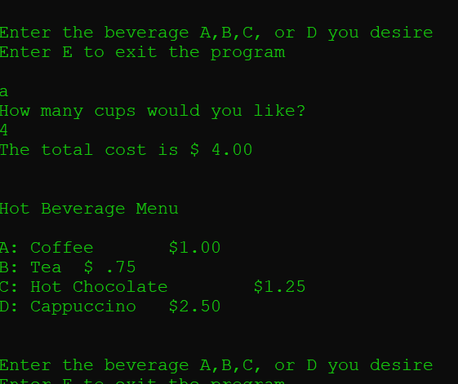

It ran because the name of the Boolean variable is the default for true

Source code

// This program displays a hot beverage menu and prompts the user to

// make a selection. A switch statement determines which item the user

// has chosen. A do-while loop repeats until the user selects item E

// from the menu.

// PLACE YOUR NAME HERE

#include <iostream>

#include <iomanip>

using namespace std;

int main()

{

// Fill in the code to define an integer variable called number,

int number;

// a floating point variable called cost,

float cost;

// and a character variable called beverage

char beverage;

bool validBeverage;

cout << fixed << showpoint << setprecision(2);

do

{

cout << endl << endl;

cout << "Hot Beverage Menu" << endl << endl;

cout << "A: Coffee $1.00" << endl;

cout << "B: Tea $ .75" << endl;

cout << "C: Hot Chocolate $1.25" << endl;

cout << "D: Cappuccino $2.50" << endl << endl << endl;

cout << "Enter the beverage A,B,C, or D you desire" << endl;

cout << "Enter E to exit the program" << endl << endl;

// Fill in the code to read in beverage

cin>>beverage;

switch (beverage)

{

case 'a':

case 'A':

case 'b':

case 'B':

case 'c':

case 'C':

case 'd':

case 'D':

validBeverage = true;

break;

default:

validBeverage = false;

}

if (validBeverage)

{

cout << "How many cups would you like?" << endl;

cin>>number;

// Fill in the code to read in number

}

// Fill in the code to begin a switch statement

// that is controlled by beverage

switch(beverage)

{

case 'a':

case 'A':

cost = number * 1.0;

cout << "The total cost is $ " << cost << endl;

break;

// Fill in the code to give the case for hot chocolate ($1.25 a cup)

case 'b':

case 'B':

cost=number*0.75;

cout << "The total cost is $ " << cost << endl;

break;

// Fill in the code to give the case for tea ( $0.75 a cup)

case 'c':

case 'C':

cost=number*1.25;

cout << "The total cost is $ " << cost << endl;

break;

// Fill in the code to give the case for cappuccino ($2.50 a cup)

case 'd':

case 'D':

cost=number*2.5;

cout << "The total cost is $ " << cost << endl;

break;

case 'e':

case 'E':

cout << " Please come again" << endl;

break;

default:

cout << "selection invalid Try again please" << endl;

// Fill in the code to write a message

// indicating an invalid selection.

}

}

while((beverage!='e')||(beverage!='E'));

// Fill in the code to finish the do-while statement with the

// condition that beverage does not equal E or e.

// Fill in the appropriate return statement

return 0;

}

5.3

1. I think the type cast is to deal with the multiple variable types in the program

I think if it is removed the numbers will not be formatted correctly

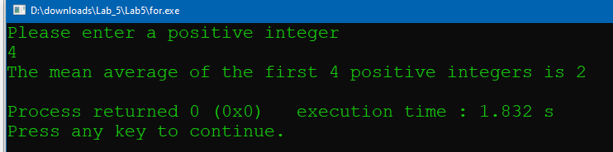

The decimal place is cutoff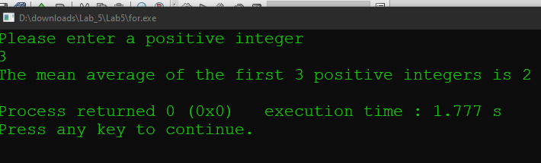

It is the same for this case

2. 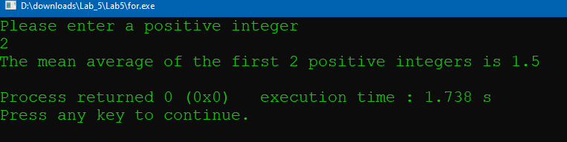

It cuts off the decimal places on the input and only uses the first number

3. 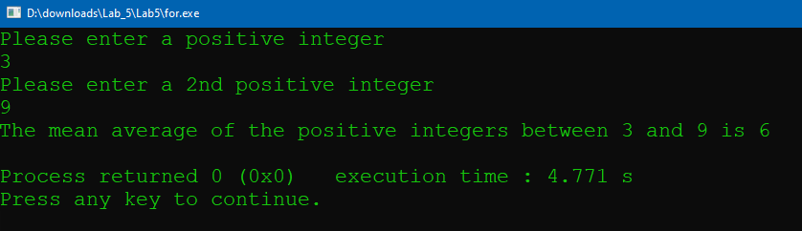

Source Code

// This program has the user input a number n and then finds the

// mean of the first n positive integers

// PLACE YOUR NAME HERE

#include <iostream>

using namespace std;

int main()

{

int value,value2; // value is some positive number n

int total = 0; // total holds the sum of the first n positive numbers

int number; // the amount of numbers

float mean; // the average of the first n positive numbers

cout << "Please enter a positive integer" << endl;

cin >> value;

cout << "Please enter a 2nd positive integer" << endl;

cin >> value2;

if (value > 0)

{

for (number = value; number <= value2; number++)

{

total = total + number;

} // curly braces are optional since there is only one statement

mean =static_cast<float>(total) / (value2-value+1); // note the use of the typecast

// operator here

cout << "The mean average of the positive integers between " << value

<< " and " << value2<<" is "<<mean << endl;

}

else

cout << "Invalid input - integer must be positive" << endl;

return 0;

}

5.4

1. 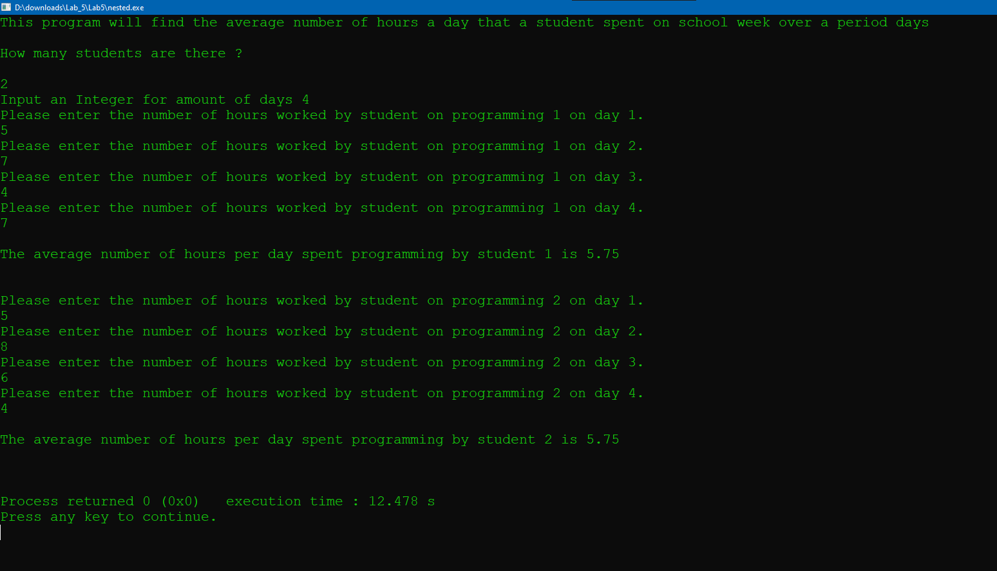

2. 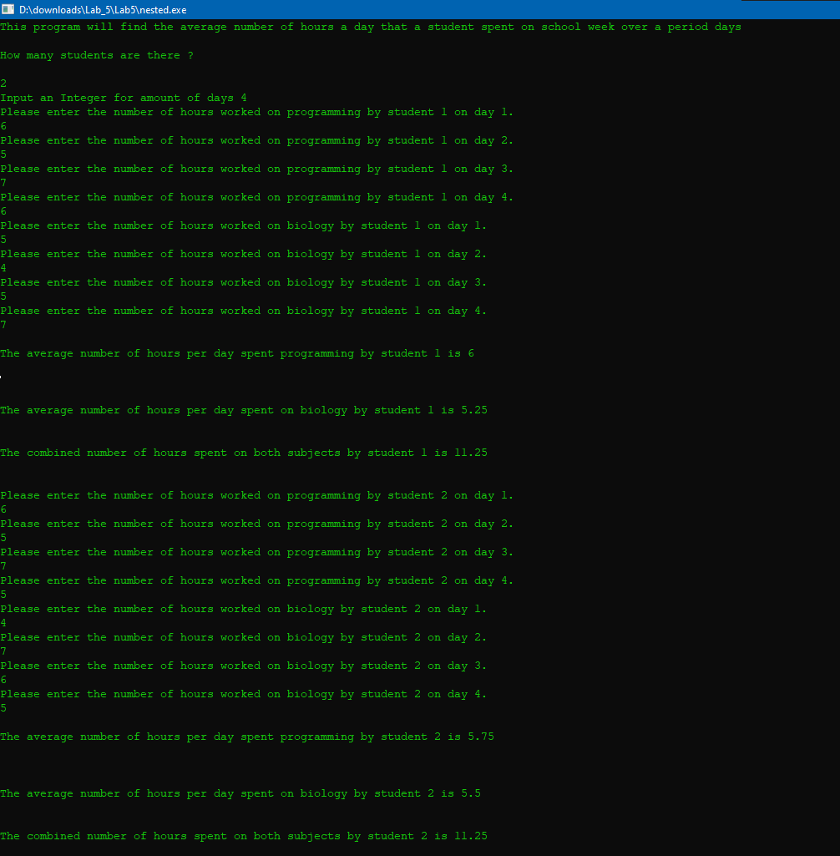

Source Code

// This program finds the average time spent programming by a student

// each day over a three day period.

// PLACE YOUR NAME HERE

#include <iostream>

using namespace std;

int main()

{

int numStudents,n;

float numHours1, total1, average1,numHours2,total2, average2,average3;

int student, day = 0; // these are the counters for the loops

cout << "This program will find the average number of hours a day"

<< " that a student spent on school week over a period days\n\n";

cout << "How many students are there ?" << endl << endl;

cin >> numStudents;

cout << "Input an Integer for amount of days ";

cin>>n;

for (student = 1; student <= numStudents; student++)

{

total1 = 0;

total2 = 0;

for (day = 1; day <= n; day++)

{

cout << "Please enter the number of hours worked on programming by student "

<< student << " on day " << day << "." << endl;

cin >> numHours1;

total1 = total1 + numHours1;

}

for (day = 1; day <= n; day++)

{

cout << "Please enter the number of hours worked on biology by student "

<< student << " on day " << day << "." << endl;

cin >> numHours2;

total2 = total2 + numHours2;

}

average1 = total1 / n;

average2 = total2 / n;

average3=(average1+average2);

cout << endl;

cout << "The average number of hours per day spent programming by "

<< "student " << student << " is " << average1

<< endl << endl << endl;

cout << endl;

cout << "The average number of hours per day spent on biology by "

<< "student " << student << " is " << average2

<< endl << endl << endl;

cout << "The combined number of hours spent on both subjects by "

<< "student " << student << " is " << average3

<< endl << endl << endl;

}

return 0;

}

5.5/3.5

1.

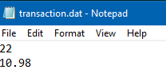

2.

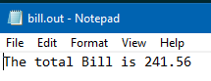

Source Code

// This program will read in the quantity of a particular item and its price.

// It will then print out the total price.

// The input will come from a data file and the output will go to

// an output file.

// PLACE YOUR NAME HERE

#include <fstream>

#include <iomanip>

#include <iostream>

using namespace std;

int main()

{

ifstream dataIn; // defines an input stream for a data file

ofstream dataOut; // defines an output stream for an output file

int quantity; // contains the amount of items purchased

float itemPrice; // contains the price of each item

float totalBill; // contains the total bill, i.e. the price of all items

dataIn.open("transaction.dat"); // This opens the file.

dataOut.open("bill.out");

// Fill in the appropriate code in the blank below

cout<< setprecision(2) << fixed << showpoint; // formatted output

dataIn>>quantity>>itemPrice;

cout<<"What is the quantity of the the item?"<<endl;

dataIn>>quantity>>itemPrice;

cout<<"What is the price of the item?"<<endl;

// Fill in the input statement that brings in the

// quantity and price of the item

// Fill in the assignment statement that determines the total bill.

totalBill=(itemPrice*quantity);

dataOut<<"The total Bill is "<<totalBill<<endl;

// Fill in the output statement that prints the total bill, with a label,

// to an output file

return 0;

}

5.6

Option 3

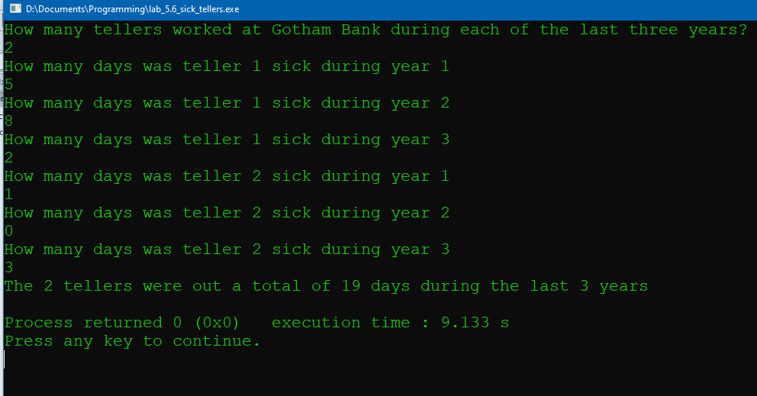

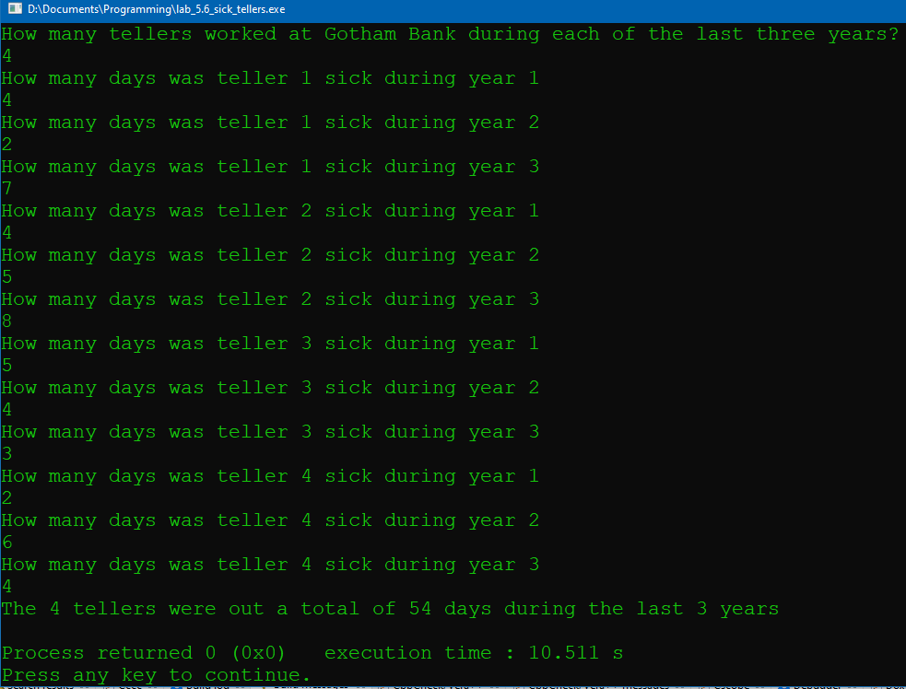

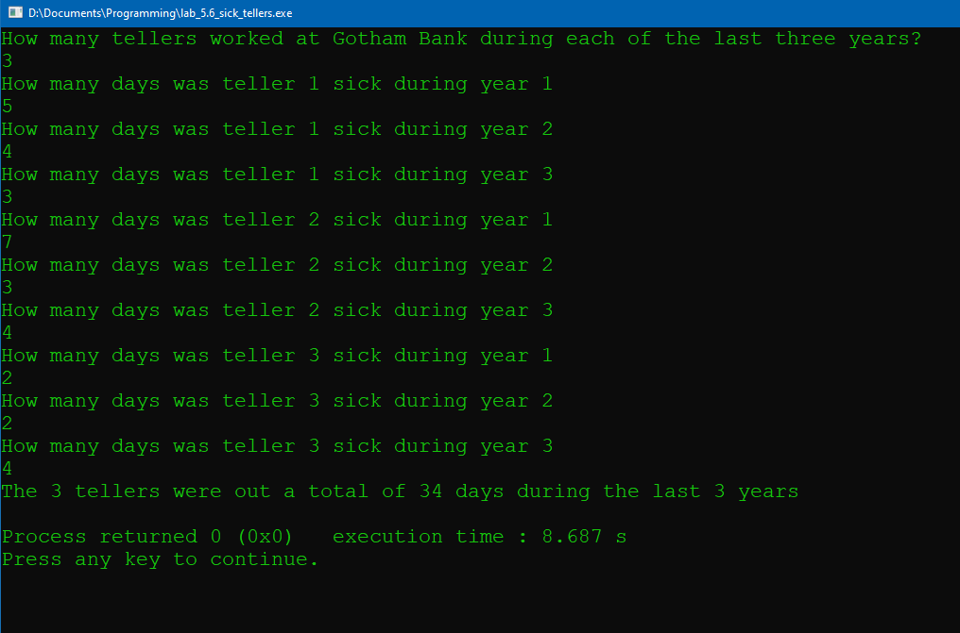

Source Code

#include <fstream>

#include <iomanip>

#include <iostream>

using namespace std;

int main()

{

int tellers;

int sick_total=0

;

cout<<"How many tellers worked at Gotham Bank during each of the last three years?"<<endl;

cin>>tellers;

//get tellers

for(int i=1; i<=tellers; i++)

{

for(int j=1; j<=3; j++)

{

int temp_sick=0;

cout<<"How many days was teller "<<i<<" sick during year "<<j<<endl;

cin>>temp_sick;

cin.clear();

sick_total+=temp_sick;

//add to total

}

}

cout<<"The "<<tellers<<" tellers were out a total of "<< sick_total<<" days during the last 3 years"<<endl;

//output

return 0;

}